|  |  |  |
| --- | --- | --- |
| **American University of Sharjah**  **College of Engineering**  Dept of Computer Science & Engg  P. O. Box 26666  Sharjah, UAE |  | **Lab Instructor:** Eng. Donthi Sankalpa  **Office:** ESB – 1036C  **Phone**: 971-6-5154826  **e-mail**: [dsankalpa@aus.edu](mailto:dsankalpa@aus.edu)  **Semester**: Fall 2023 |

Lab #2 – Introduction to Logic Gates – ELVISS board

**Objectives**

* Use of switches as inputs and LEDs as outputs.
* Understand and test operations of basic logic gates.
* Determine experimentally the truth tables for the AND, OR, and inverter gates.
* Interpret the Data Sheet of the used chips

**Lab Equipment and Circuit Components**

* 1. **Equipment** 
     + 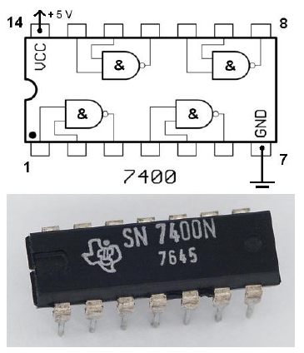ELVIS III Board

Figure 1. 7400 NAND DIP

* 1. **Circuit Components**
     + 7404 inverter
     + 7408 AND
     + 7432 OR

**Introduction:**

***Logic gates and Integrated Circuits:*** The 7400 family of Integrated Circuits (ICs) will be used throughout this course. The chips come in various packages, but the package used in these labs is a dual in-line package, otherwise known as a DIP as shown in Figure 1. In order to determine the polarity of the chip, a notch is put on one side of the chip. From a top view, pin one is on the left of the notch with other pins numbered sequentially in a counterclockwise manner.

The 7400 series is implemented using Transistor–transistor logic (TTL), which uses bipolar transistors (BJT) to form its integrated circuits. The 7400 family has many subfamilies made for special considerations, referred to by letters written after the family name; such as 74LS08, these subfamilies are summarized in Table 1.

|  |  |
| --- | --- |
| **Family** | **Meaning** |
| 74 – | Standard TTL |
| 74L | Low-power |
| 74H | High speed |
| 74S | High-speed Schottky |
| 74LS | Low-power Schottky |
| **Table 1. 7400 Families** | |

Figure 2 shows the internal logic of the 7404, 7408, 7432 chips.

***Breadboard:*** In order to build the circuit, a digital design kit that contains a power supply, switches for input, light emitting diodes (LEDs), and a breadboard will be used. Figure 3.a shows a common breadboard, while Figure 3.b

shows how each set of pins are tied together electronically. Watch this [video](https://youtu.be/6WReFkfrUIk) to understand how a breadboard works.

|  |  |  |
| --- | --- | --- |
| Image result |  |  |
| 7404 hex inverters | 7408 Quad 2-input AND Gates | 7432 Quad 2-input OR Gates |
| **Figure 2. Connection diagram of 7404, 7408m and 7432** | | |

|  |  |
| --- | --- |
|  |  |
| **Figure 3.a: Breadboard** | **Figure 3.b Common connections** |

**Steps to run the NI ELVIS III Board:**

The NI Educational Laboratory Virtual Instrumentation Suite III (NI ELVIS™ III) is an engineering laboratory solution for project-based learning.

It combines a suite of commonly used lab instruments, flexible analog and digital I/Os, and a high-performance embedded controller. Its open software architecture supports a wide range of experimental exploration, allowing students to quickly learn concepts.

NI ELVIS III is equipped with a Prototyping Board with different Digital Channels (DIO), Analog Channels (AI, AO) and fixed power supplies (3.3V, 5V, 15V, -15V). Moreover, it is equipped with multiple user peripherals.

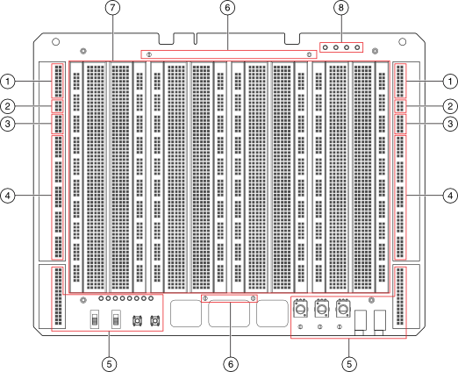

|  |  |  |  |
| --- | --- | --- | --- |
| 1. Analog Input | 1. Analog Output | 1. Fixed User Power Supplies | 1. Digital I/O |
| 1. User Peripherals | 1. Digital Ground | 1. Central Build Area (Breadboard) | 1. Fixed User Power Supplies LEDs |

During your COE 221 Labs, you will be supplying your digital chips with the fixed 5V supply and the DGND. Moreover, you will be using the below software interface to control your chips’ inputs and monitor their outputs.

In order to switch ON the NI ELVIS III you need to:

1. Switch on the board’s main power supply from the back of the interface.
2. Switch on the prototyping board by pressing on the “APPLICATION BOARD POWER” button on the top left of your interface.

**Steps to run the NI ELVIS III COE 221L Interface:**

|  |  |
| --- | --- |
| 1. Go to “C:\COE221 Interface” |  |
| 1. Double Click on COE221 Interface |  |
| 1. From the LabVIEW project explorer expand NI-ELVIS-III then double click on Main.vi |  |
| 1. Click on the Run button |  |

The interface is divided into three parts:

1. Outputs which will reflect the status of the NI ELVIS Board LEDs
2. Inputs which are used to control the input Digital Channels of the NI ELVIS III Board
3. Multimeter which is used to measure voltage values

**Lab Activities:**

1. Given the following digital circuit:

1. Implement the circuit on the NI ELVIS and verify your answer for a.

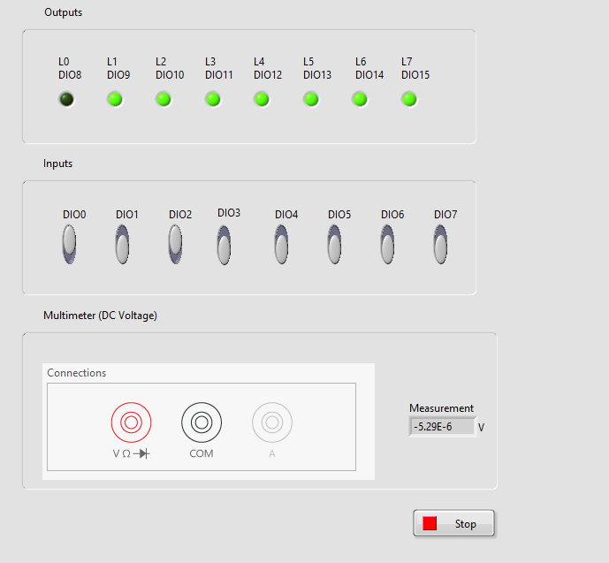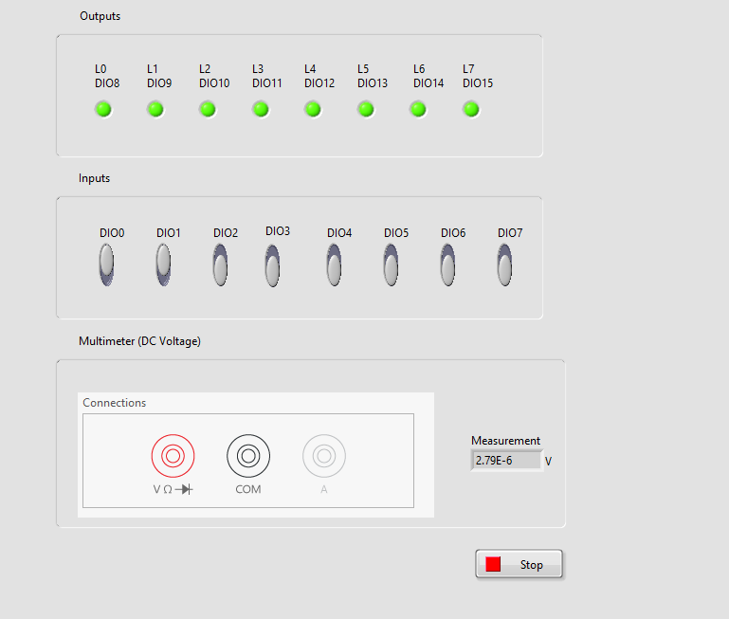

1. Given the following Boolean expression:
$$F\left(X,Y,Z\right)=\overline{X}.Y+X.Z+X.\overline{Y}.\overline{Z}$$

2. Build the truth table for F.

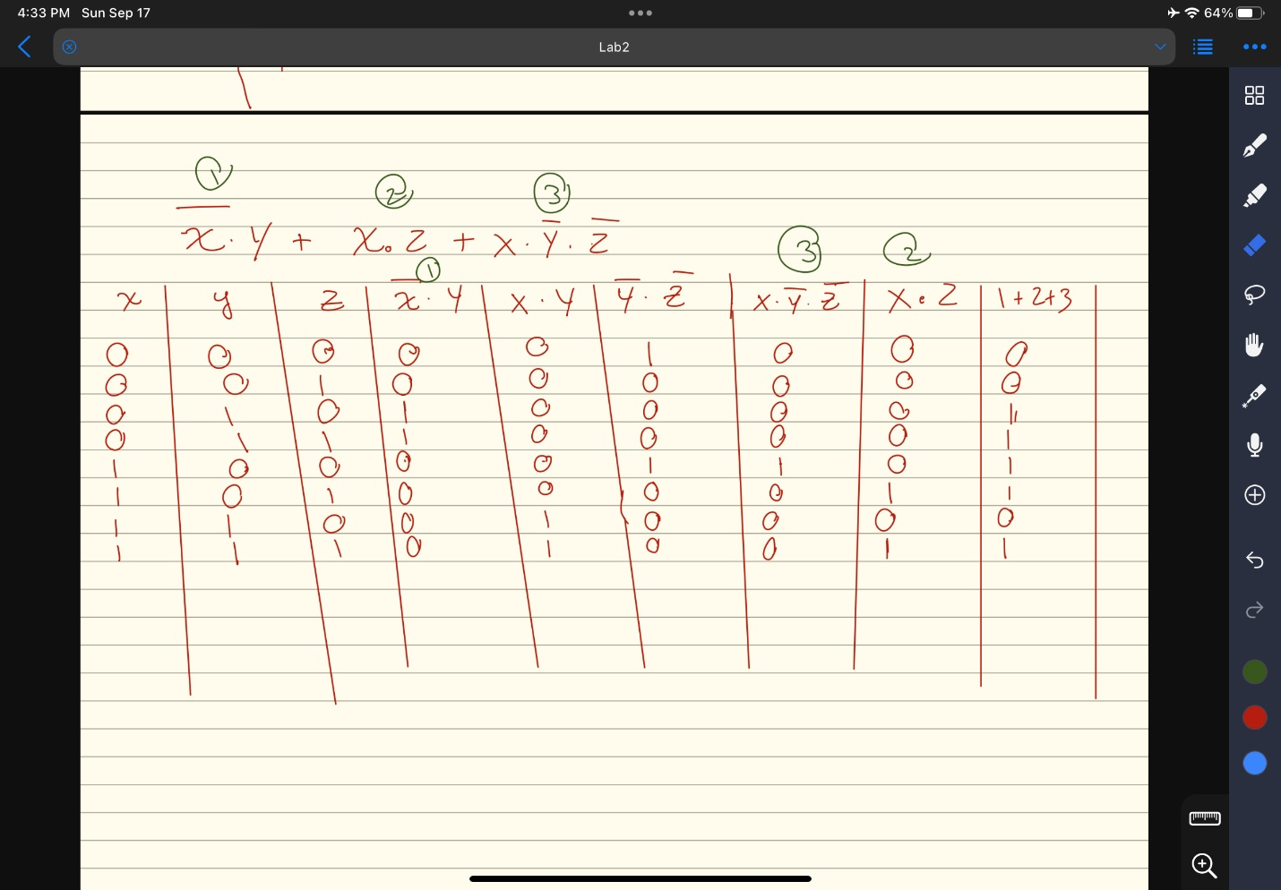

1. Simulate the circuit in part b (using the simulation tool that was used in the previous lab) to verify your truth table obtained in part a.

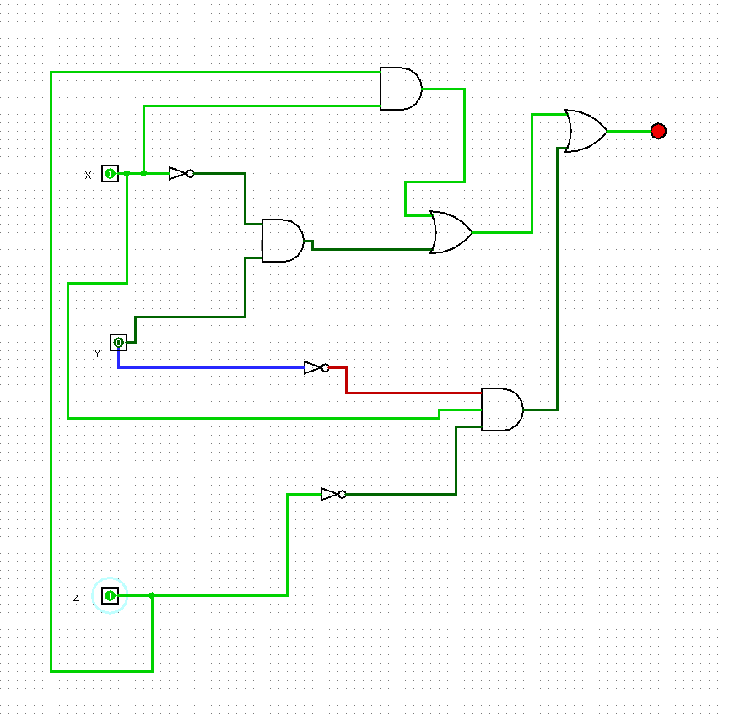

1. Implement the circuit on the NI ELVIS in part b.

